SIMATS ENGINEERING (SAVEETHA SCHOOL OF ENGINEERING)
Department of Computer Science and Engineering

ASSESSMENT TOOL 3 – DEBUGGING & OPTIMISATION TASK
Course Code: | CSA06 | Course Title: | Design and Analysis of Algorithms
CO Assessed: | CO2 – Manipulation (BL1, BL2, BL3) | Assessment: | Assessment Tool 3 – Debugging &  Optimisation Task
Weightage: | 10% of CIA | Total Marks: | 100
CO2 Statement: | Apply Brute Force technique to solve sorting, searching, Closest-Pair and Convex-Hull problems  (BL1, BL2, BL3)
Student Name: | N.Srinivas | Reg. No.: | 192372358
Section / Batch: | CSE(AI) | Date: | 29-07-2026

Instructions to Students
- Answer the following question. Total Marks: 100.
- Carefully analyze the given program/code segment before identifying errors.
- Clearly identify logical, syntactical, and performance-related issues in the code.
- Apply systematic debugging techniques to correct the errors effectively.
- Optimize the given solution by improving efficiency, reducing unnecessary computations, or enhancing time complexity wherever possible.
- Provide proper justification for all corrections and optimization decisions.
- Write clean, structured, and well-documented code with appropriate comments.
- Maintain clarity, logical reasoning, and technical accuracy throughout the solution.

Question Type | Focus Area | Questions
Debugging &  Optimisation Task | Identify errors, debug programs, and optimize algorithm efficiency using appropriate techniques | Q1

SECTION A – DEBUGGING & OPTIMISATION TASK

Code of Conduct
I __________________________ (Name / Reg No) certify that this submission is my original work and that I have adhered to the guidelines specified for this assessment. I understand that any violation of academic integrity rules will result in disciplinary action.
Signature of the Student: _________________________

RUBRICS FOR CALCULATION

Criteria | Wt. | Level 4 – Exemplary | Level 3 –  Proficient | Level 2 –  Developing | Level 1 –  Beginning
Problem  Identification | 20% | Accurately identifies all errors and root causes with clear understanding | Identifies most errors with minor gaps | Identifies some errors but misses key issues | Unable to identify errors correctly
Debugging | 25% | Applies systematic debugging techniques effectively to resolve issues | Uses appropriate debugging methods with minor errors | Limited debugging approach; requires guidance | Unable to debug or resolve issues
Optimization | 20% | Optimizes code by significantly improving time complexity using efficient algorithms | Improves time complexity with minor gaps in efficiency | Limited improvement in time complexity | No improvement;  inefficient approach retained
Analysis | 20% | Demonstrates strong logical reasoning and clear justification of solutions | Shows reasonable  analysis with some justification | Limited analysis; weak reasoning | No analytical reasoning demonstrated
Code Quality | 15% | Produces clean, wellstructured code with proper comments and documentation | Code is mostly clear with minor documentation gaps | Code lacks structure and proper documentation | Poorly written code with no documentation

Marks Evaluation:
Criteria |  | Wt. | Level 4 –  Exemplary | Level 3 –  Proficient | Level 2 –  Developing | Level 1 –  Beginning
Problem Identification |  | 20%
Debugging |  | 25%
Optimization |  | 20%
Analysis |  | 20%
Code Quality |  | 15%
Total Marks (100):

Faculty In-charge | Course Coordinator | Head of Department
Name: | Name: | Name:
Signature: _______________ | Signature: _______________ | Signature: _______________
Date: ___________________ | Date: ___________________ | Date: ___________________

Q31. Debugging Selection Sort Code (Incorrect Outer Loop Range)

The following Selection Sort implementation skips the final required pass because of an incorrect outer loop boundary, which may leave the array partially unsorted for certain inputs. Carefully analyze the loop range and explain why the remaining unsorted portion is not handled correctly. Apply systematic debugging to correct the iteration structure and ensure complete sorting. Optimize the implementation by avoiding unnecessary swaps when the minimum element is already in the correct position. Analyze the time complexity of the corrected version and rewrite the final optimized code with proper comments.
def selection_sort(arr):
n = len(arr)
for i in range(n-2): # ERROR
min_idx = i
for j in range(i+1, n):
if arr[j] < arr[min_idx]:
min_idx = j
arr[i], arr[min_idx] = arr[min_idx], arr[i]
return arr

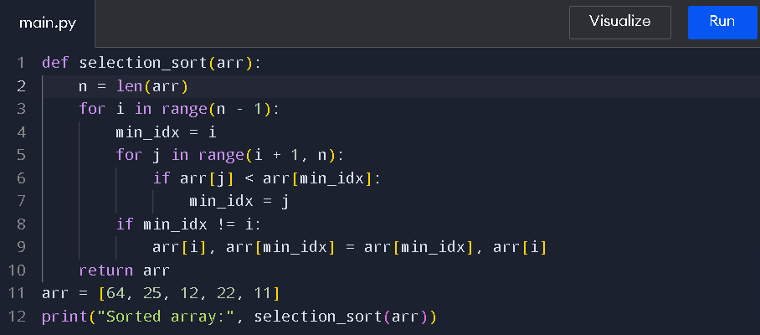

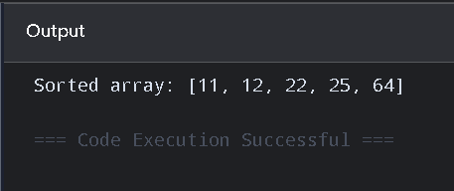

The given Selection Sort program contains an error in the outer loop. The statement range(n-2) performs only n-2 passes, so the sorting process may not be completed correctly. Selection Sort requires n-1 passes because each pass places the smallest element of the unsorted portion in its correct position.

The algorithm first assumes that the current position contains the minimum element. It then compares this element with all remaining elements and finds the actual minimum. After finding the minimum element, it is placed in the correct position.

The code can also be optimized by avoiding an unnecessary swap when the minimum element is already in the correct position. This is done using the condition if min_idx != i.

The corrected Selection Sort has a time complexity of O(n²) in the best, average, and worst cases because it performs comparisons for every unsorted portion. Its space complexity is O(1) because it sorts the array in-place. The optimization reduces unnecessary swaps but does not change the overall time complexity.

Thus, correcting the loop boundary and avoiding unnecessary swaps makes the Selection Sort implementation complete and slightly more efficient.

